Table of Contents

**1.Introduction** 1

**1.1 Purpose** 1

**1.2 Scope of Project** 1

**1.2.1 Main Objective** 1

**1.2.2 Specific Goals** 1

**1.3 Overview of Document** 1

**2. Users** 2

**2.1 Who are users?** 2

**2.2 Use Cases** 2

**2.3 Use Case Scenarios** 3

**3. System** 4

**3.1 Development Environment** 4

**3.2 Target Environment** 5

**3.3 Functional Requirements** 6

**3.3.1 Issues** 6

**3.3.2 Major Subsystems** 6

**3.3.3 Major Functions** 6

**3.3.4 Major Classes Identified** 7

**3.3.5 Minor System Functions** 7

**3.4 User Interface Specifications** 7

**3.5 Non-Functional Requirements** 9

**3.5.1 Management** 9

**3.5.2 Technical** 9

**3.5.3 Performance** 9

**3.5.4 Security** 9

**3.6 System Evolution/Maintenance** 10

**4. Other Required Deliverables** 10

**5. Risks** 10

**6. References** 10

# **1.Introduction**

This section describes the purpose of the document and the scope of the project which includes the main objective of the application, its specific goals, and an overview of the document.

## **1.1 Purpose**

The purpose of this document is to describe all of the required details for the customer for developing an electronic task logger application. It outlines how the application needs to look and the behavior of the application with respect to the customer. The customer’s need of the application is analyzed and how the application is used by the user is described. It provides a better understanding on how the application works.

This helps the developers in designing the user interface and determining the functionality, while developing the application. This document also describes the hardware and software requirements needed for the application. This application is for writing notes regarding events and also must be able to search for it based on event name, event type and date.

## **1.2 Scope of Project**

This section describes the scope of the project by outlining its objectives and goals. This gives the developers a well-documented outline that is available for them to refer back to when designing, implementing, and testing the application.

### **1.2.1 Main Objective**

This project allows the user to write notes about events. It keeps a record of events in an e-format accessible on a tablet. It allows the user to search for an event of a certain type, name, or timespan and displays the results.

### **1.2.2 Specific Goals**

The customer needs an application that is able to store a log of events electronically instead of them doing it manually. This application should provide the following functionalities: drop-down menus, icons, buttons, and an editable text box. The drop-down menu is used to select the event or person from a list of events and individuals. Menus will act as user interface pages, where specific operations can be accomplished, or different operations can be navigated to by the user. The operations and navigation will be completed through the use of buttons. The user will be allowed to enter a comment, either from a keyboard or a stylus, into an editable text box. This comment will be associated with the selected event and persons, which will be stored to the system through a button operation. The application will also need a search function, which will be implemented through one of the menu pages. The search will be able to be filtered by the user. This filter will include: event type, persons, start and end date, and keywords. The search will be completed utilizing a button, which will then display the results of the filtered search. This search will improve current method of searching by the user.

## **1.3 Overview of Document**

This document is intended to provide information about the features of the application to the customer and the developers. This document provides hardware and software requirements along with requirements for the user interface needed, as well as describes the major functionalities. The following section describes the users interacting with the system, the application goals, as well as information about the target environments, development environments, the functional and non-functional requirements of the application, other required deliverables, and the risks associated with this project.

# **2. Users**

Users are the individuals who will utilize the application every day. This application is being developed for a single user.

## **2.1 Who are users?**

The user of this application is Dr. Catherine Stringfellow. She is a professor at Midwestern State University in the McCoy College of Science, Mathematics, and Engineering for the Department of Computer Science. She has numerous tasks to complete and participate in on a daily basis.

She currently documents her tasks by manually writing them in a small notebook, that she has access to when she is in her office. This notebook serves as a data storage device for her so that she can recall information on the tasks she has completed, which may include: the type of task completed, the person or people she was interacting with, the date the task was completed on, the time the task started or was completed on, as well as any personal notes or comments about completing the task.

She is currently looking to improve on this practice by being able to do this task logging on an electronic device. This improvement should include the following features: be able to store the task and the information associated with it, while also being able to be searched quickly for specific tasks and information associated with them, which can be displayed to her for quick access. This will improve searching manually through her notebook, as well as display certain tasks from a filtering process on the same page, which is impossible in her current process. This electronic task logger is a system that will have the features and functionality of her current process of logging tasks, as well as some additional beneficial features which have been stated above.

This application would work by allowing her to select from a dropdown menu the type of task she is currently logging, with the possibility of adding a new task if necessary. She would then be able to select a person, multiple persons, or organizations to be associated with the task if they are necessary, or not be selected if the task was not social. She will then be able to enter a comment associated with this task noting anything of importance and significance she identifies. This information along with the current time and date will be captured and stored to the device. Since this is a stand-alone application, specifically for Dr. Stringfellow, the information will be stored on the device’s local storage. Utilizing the space, a feature to delete by date will most likely be important as years of tasks start to accumulate and should be added. This application should be able to be utilized by Dr. Stringfellow while she is working diligently, and not disrupt her daily manual logging routine. It should enhance and quicken the task of logging itself.

## **2.2 Use Cases**

This section describes the relationship between the use cases, actor or user, and the system. The use case diagram also establishes the behavior of the application in a visual way. Below is a use case diagram, Figure 1., that will visually depict the roles and functionality required of the project we are developing.

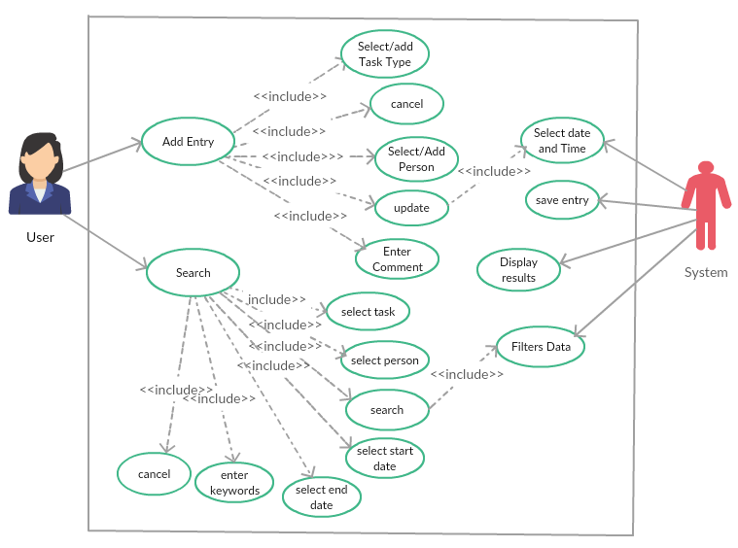

Figure 1. Use Case Diagram.

Figure 1. shows the process required to add a task, search for a task and update a task. User can add a task from the home page. Task includes type of the task, persons, comments and date which is automatically generated by the system. Update task will update the system with the newly input task specification. User also can search for a task either by selecting the task type, person or the timespan, based on the input system filters the data and shows the results.

## **2.3 Use Case Scenarios**

This section will contain scenarios that will describe a series of steps the user will go through to accomplish a certain task. A few examples of different tasks, or use cases, will be described below.

1. User searches for entry relating to a person 1. User selects Search. 2. User selects Person name from the drop-down list. 3. User selects Search. 4. System filters data. 5. User views the results, displayed by the System.

Extensions: 1. If there is no data entry on that person name, then system will display no results found.

1. User adds an Entry 1. User selects Add Entry. 2. User selects Person name from drop-down list. 3. User selects Task type from drop-down list. 4. User types in a Comment associated with the Entry. 5. User submits the Entry through Update. 6. System selects current Date and Time. 7. System saves the Entry.

Extensions: 1. If Task type is not in the list, then the user has to type it in the drop-down list which will add it to the list for future uses.

1. User Searches for Entry 1. User selects Search. 2. User selects Task type from drop-down list. 3. User selects Search. 4. System filters data. 5. User views the results, displayed by the System.

Extensions: 1. If there is no data entered relating to that Task type, then system will display no results found.

1. User Search based on Keyword 1. User selects Search. 2. User enters the keyword, which are entered in the Keywords section. 3. User selects Search. 4. System filters data. 5. User views the results, displayed by the System.

Extensions: 1. If there is no data entered with the keyword, then system will display no results found.

# **3. System**

This section describes the system of the project in terms of the development environment, target environment, functional requirements, user interface specifications, non-functional requirements, and system evolution and maintenance.

## **3.1 Development Environment**

The development environment for the project will consist of hardware and software as follows:

Hardware will include:

TriNetra team member’s personal computers.

Dr. Stringfellow’s current tablet, if available.

Software utilized will include:

Windows 10

Android 7

Visual Studio 2017 Community Edition

Google Chrome

Ionic

Apache Cordova

## **3.2 Target Environment**

This project will be designed for the Samsung Galaxy Tab S3. It is displayed below in Figure 2., which is followed by its hardware and software specifications.

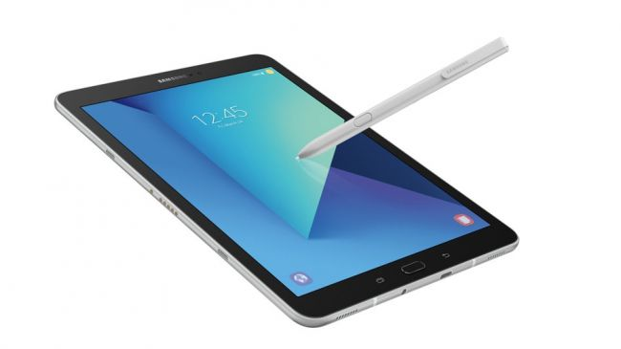

Figure 2. Samsung Galaxy Tab S3

Hardware:

Screen Size: 9.7 inch

Resolution: 1536 x 2048

CPU: Snapdragon 820

RAM: 4GB

Storage: 32GB

Battery: 6,000mAh

Dimensions: 237.3 x 169 x 6mm

S-Pen Stylus

Software:

Android 7

Application developed by TriNetra

Samsung Handwriting Recognition Software with S-Pen Stylus

Alternative: Google Handwriting Input Application

## **3.3 Functional Requirements**

This section will discuss the functional requirements of the project. These are statements of services that the system should provide, how the system should react to particular inputs and how the system should behave in particular situations.

### **3.3.1 Issues**

The requirements for this project are for the user to add a specific entry that can be associated with persons, dates, times, and comments to the system. These entries can then be searched by the user utilizing filters for tasks and the items associated with tasks to find a specific task or tasks. When inputting data, a major function is handwriting to text recognition which will be utilized for entering comments for each entry.

### **3.3.2 Major Subsystems**

The major subsystems for this project are navigating between the Add Entry and Search pages, through the use of buttons on the Home page. There will also be cancel buttons on the Add Entry and Search pages which can navigate back to the Home page.

### **3.3.3 Major Functions**

3.3.3.1 Add Entry: This function will display the user interface that will allow for a new task to entered and added to the system.

3.3.3.2 Select/Add Task Type: This function will allow the user to select one of the existing tasks or be able to add a new task if needed to the collection of tasks.

3.3.3.3 Select/Add Person: This function will allow the user to select one or many of the existing persons or organizations or be able to add a new person or organization if needed to the collection of persons.

3.3.3.4 Enter Comment: This function will allow the user to enter input that will be assigned to the current task. This function will be designed to work with handwriting to text recognition software.

3.3.3.5 Update: This function will update the system with the newly input task specifications.

3.3.3.6 Search: This function will display the user interface that will allow for a task to be searched and displayed.

3.3.3.7 Select Filter Start Date: This function will allow the user to input a start date to filter their search.

3.3.3.8 Select Filter End Date: This function will allow the user to input an end date to filter their search.

3.3.3.9. Select Filter Task Type: This function will allow the user to select one of the existing tasks to filter their search.

3.3.3.10 Select Filter Person: This function will allow the user to select one or many of the existing persons to filter their search.

3.3.3.11 Select Filter Keywords: This function will allow the user to provide input that will be utilized to filter their search in the comment attribute. This function will be designed to work with handwriting to text recognition software.

3.3.3.12 Cancel: This function will allow the user to navigate to the Home Page.

### **3.3.4 Major Classes Identified**

Add Entry

Search

Home

### **3.3.5 Minor System Functions**

3.3.5.1 Delete: This function will delete all tasks with the input specified by the user, it will be prioritized with a start and an ending date. It may be expanded upon to delete particular tasks or persons.

3.3.5.2 Stylus Integration: This function will allow the user to enter input to the Enter Comment and Keywords functions utilizing a stylus pen. Samsung has integrated software that allows for handwriting to text recognition. If it is not accessible during the execution of our application, an alternative is to utilize Google Handwriting Input Application for a keyboard that allows for handwriting to text recognition.

## **3.4 User Interface Specifications**

The preliminary user interfaces are depicted in Figure 3., Figure 4., and Figure 5. Each one of these figures displays one screen of the user interface respectively.

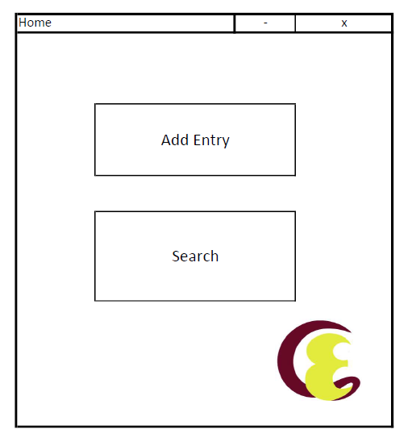

Figure 3. A prototype user interface for the Home Page of the application.

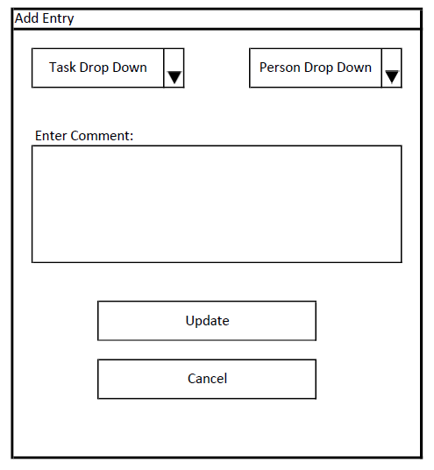

Figure 4. A prototype user interface for the Add Entry Page of the application.

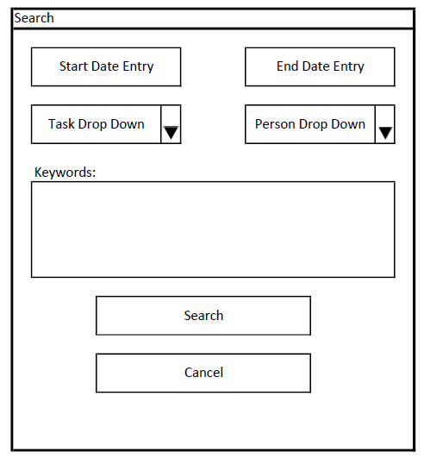

Figure 5. A prototype user interface for Search Page of our application.

In accordance with the client, the user interface the Home will have two buttons to navigate to the other pages, one for Add Entry and another for Search. The user interface for the Add Entry will have drop down menus where the task and persons may be selected. A large area to input text, possibly from a stylus, for an associated comment, followed by an update button to save the task into storage and a cancel button to navigate back to Home. The user interface for the Search will have entry points for start date and end date inputs, as well as drop down menus to select tasks and persons. A medium sized keywords area can be utilized, possibly with a stylus, for text input that will filter the search based on words present in previous input comments. The search button will complete the search based on the appropriate filters, and the cancel button will navigate back to Home. The search results are still undecided on how they will be displayed.

## **3.5 Non-Functional Requirements**

This section will discuss the non-functional requirements of the project. These are constraints on the services or functions offered by the system such as timing constraints, constraints on the development process, and standards. This section focuses on constraints pertaining to the management, technical, performance, and security aspects of the project.

### **3.5.1 Management**

Team TriNetra has three members, so management will be handled by the team leader. The team leader will speak with members of the team during meetings and appoint tasks to an individual or individuals. The team leader will accept feedback from group members to help ensure a fair workload for all team members as the project progresses. Further management details can be found in the project plan document.

### **3.5.2 Technical**

This application is developed for a Samsung Galaxy Tab S3. The implementation of this application will consist of using Angular JavaScript, CSS, HTML, while utilizing Apache Cordova and Ionic Frameworks. At our current iteration a JSON file will be utilized to store data in a dictionary environment for ease of access within a structured environment while utilizing the least amount of storage possible. This application will also be attempting to utilize certain functionalities within the Samsung Galaxy Tab S3, some being the handwriting recognition software capability and handwriting to text function through the use of the stylus. An alternative is to utilize Google Handwriting Input Application for access to a keyboard that has handwriting to text recognition and functionality.

### **3.5.3 Performance**

This application is going to improve the efficiency in which the client is manually logging her tasks currently. This is to be done with a small, lightweight data storage device similar to her hardware currently. However, data will be stored in such a way as to not have to locate a specific page or address to enter the data. It will also improve efficiency in the way that searching for a specific task or tasks are to be carried out, as opposed to manually searching page by page. To ensure reliability this application will use a simple data structure for data storage, that will also help to improve the speed of access to that data. This application is aimed on improving performance in efficiency and usability over the current method for our client, while maintaining if not improving the same level of reliability.

### **3.5.4 Security**

In order to secure individual data, the product will be utilizing local storage on the device. This is to not allow for any outside sources to come into contact with the data. Only the system administrator, the one client, will have the ability to deliver and alter the approval data on the system.

### **3.6 System Evolution/Maintenance**

The application will be developed with prototypes and builds, where the client provides feedback accordingly. This application is planned to be designed and fully functional by December 3, 2018, when maintenance will cease. The client will have the application delivered along with excellent documentation for the application.

# **4. Other Required Deliverables**

This project will require a user manual for the client. It will provide detailed instructions on the functionality of the application, as well as describe and explain some use cases with educational and helpful diagrams.

# **5. Risks**

Memory corruption may occur due to hardware vulnerabilities over time. There is the risk of data loss if the device has to restore to factory settings as the data will be kept on the device to aid with security. There is a risk of not being able to utilize the stylus functionality of the Samsung Galaxy S3 Tab as it requires some unfamiliar integration work with the hardware and software systems of the target environment. There is a risk of development progressing much slower than expected as team TriNetra will be learning Angular JavaScript, Apache Cordova Plug-Ins, and the Ionic Frameworks for the implementation phase of this application’s development. We are anticipating difficulties with the implementation and design of the delete functionality, and the cascading effects it may have within the data. Also, with any advancing technology there is a risk for this application to become obsolete, as newer and supposedly better software becomes available.

# **6. References**

This section will contain a list of references Team TriNetra utilized in order to produce this document.

[1] Iskandar, O. and Jones, M. and Moss, B. and Wuthrich, C. *Munitions Storage System Requirements Specification Document*, Sept 2018. (https://d2l.mwsu.edu/d2l/le/content/57393/viewContent/589244/View)

[2] John, A. and Norris, J. and Keown, R. and Flake, P. and Suzuki, K., *Software Requirements Specification for Strength and Conditioning Online Report System, Release 1.0*, Sept 2018. (https://d2l.mwsu.edu/d2l/le/content/57393/viewContent/589245/View)

[3] Pressman, R., *Software Engineering: A Practitioner’s Approach, 7th Ed.*, McGraw-Hill Higher Education, Boston, Mass., 2010.

[4] Stringfellow, C. *Requirements Specification Outline,* Sept 2018. (https://d2l.mwsu.edu/d2l/le/content/57393/viewContent/589270/View)